Aldon Sample Audit History Reports

[Rocket Aldon® Report Manager](http://www.aldon.com/products/it-compliance/reporting-at-a-glance) is a web-based report management solution built on a widely-used and actively-supported open source software reporting technology. It allows you to view, track, understand, and manage all software development data and generate the compliance reports necessary for simplified audit compliance, and successfully create timely software delivery. Through our centralized reporting system home screen, you can easily select and run reports from one of our pre-packaged templates or create customized IT reporting to meet your needs. You can rapidly generate reports regarding task status, activity history, release setup, change request backlog items, and lifecycle progress using selection criteria so you can focus on the most pertinent information.

Aldon Report Manager comes shipped with almost thirty canned reports, with new ones coming on a frequent basis. Here are some sample audit history reports.

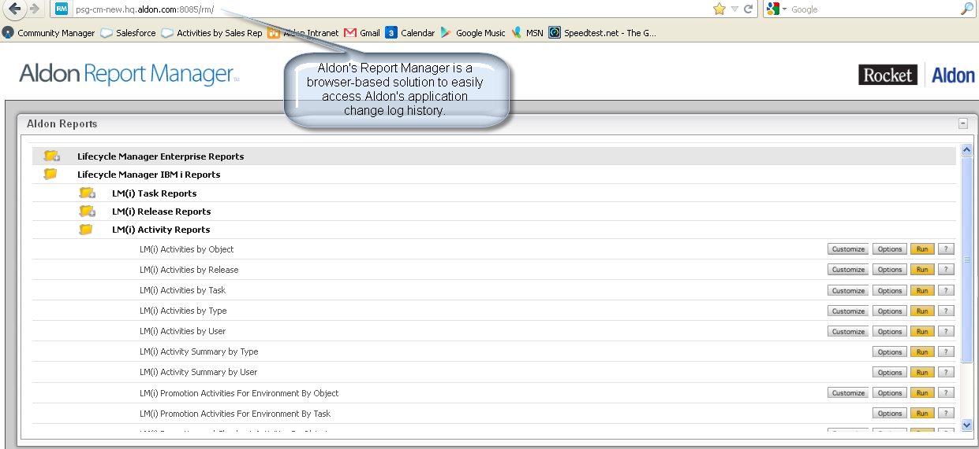

This screen shot shows how Aldon’s Report Manager lets you save the reports (and their parameters) that you run frequently into your own section. Now all you need to do is press “Run”!

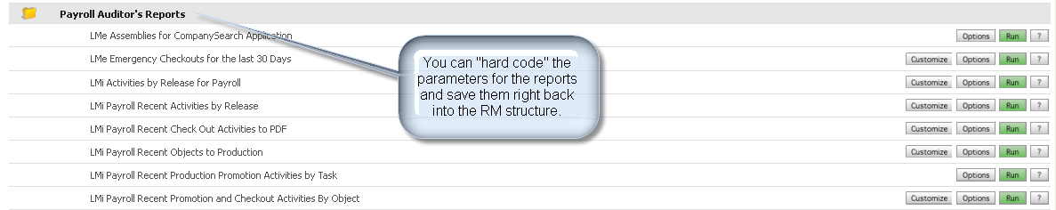

This report documents that Aldon is managing a specific application and shows the settings and other pertinent information about that application.   
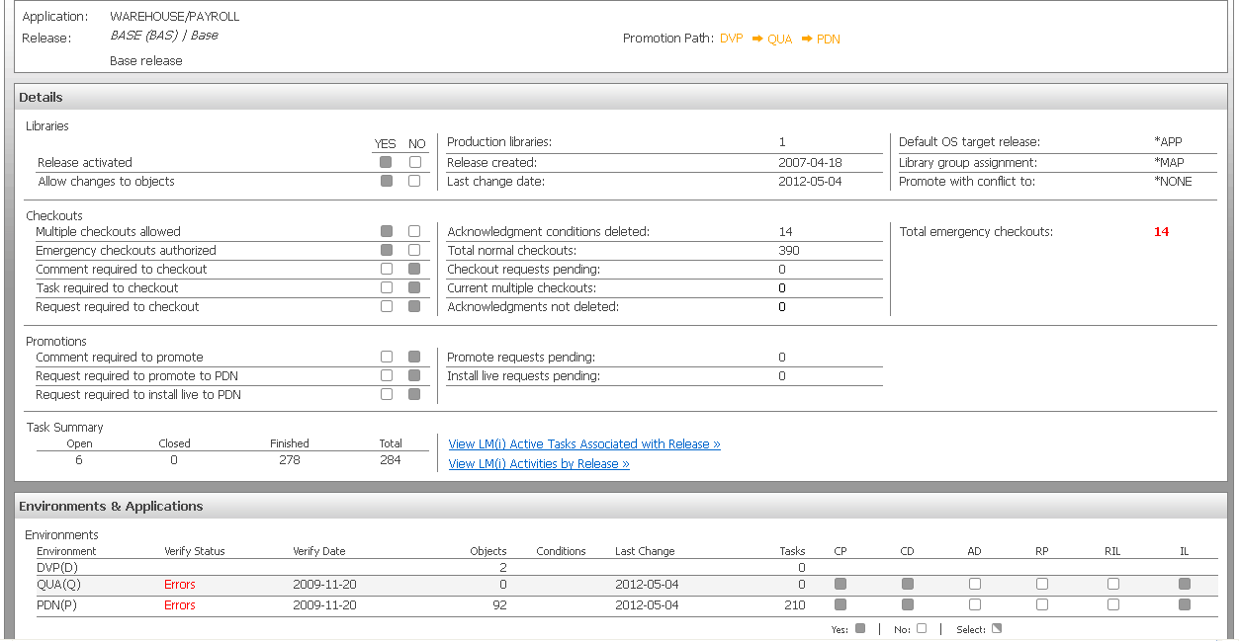

This report shows that Aldon was responsible for deploying and installing the changed objects on the live production machine.

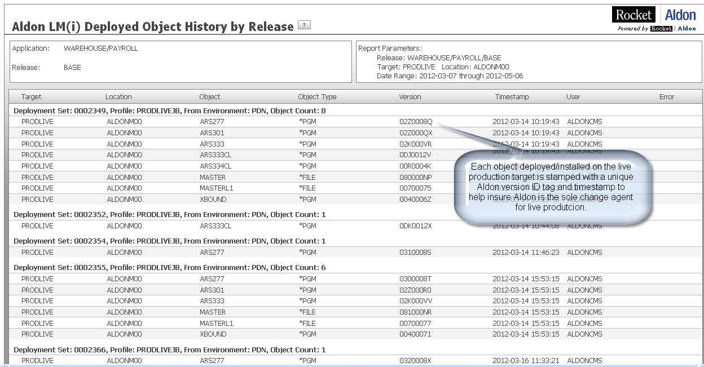

This report shows that Aldon is monitoring every activity taken against the objects that it is managing. 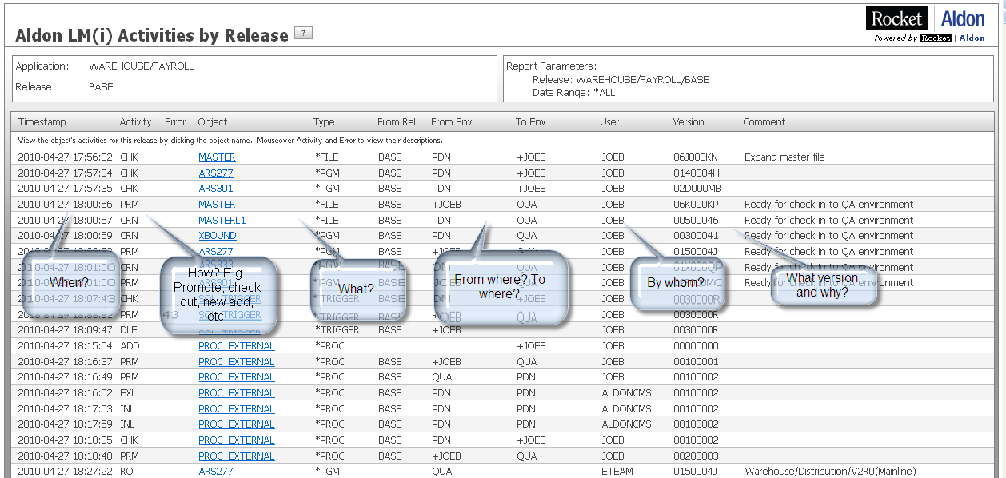

This report ties together the objects changed in a specific date range back to the task for which they were changed.

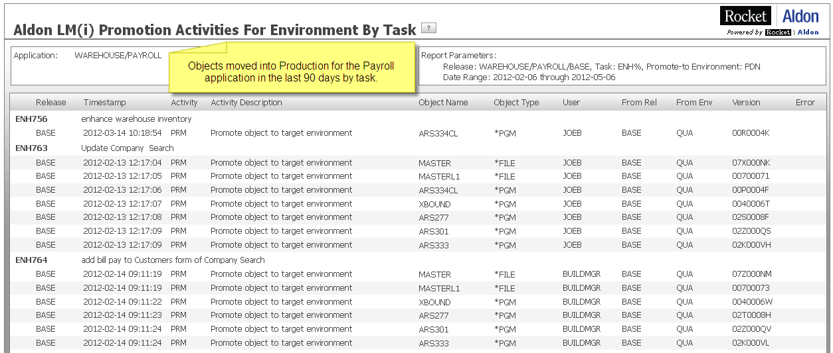

Here we see what permissions a particular user has to the applications managed by LM(i). The grey boxes indicate the user has that permission. Hovering the mouse over any box will generate a pop-up of that box’s permission, i.e. “Request Checkout”.

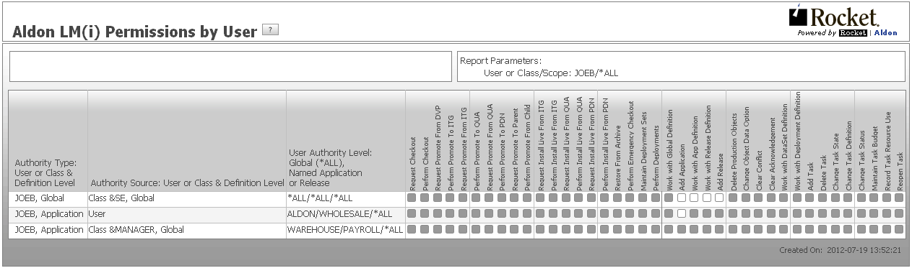

This is a similar permissions report, only it focuses on a single application and shows all groups and individuals and what permissions each one has.

